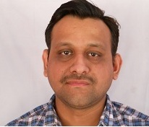
Mr. Vikas Pandey is an Associate Professor at Bhilai Institute of Technology, Durg (C.G). He is pursuing PhD at Chhattisgarh Swami Vivekananda Technical University, Bhilai. His broad research interests are in the Areas Natural Languages Processing and Machine Translation. He is having publications in several Nation/International journals and conferences

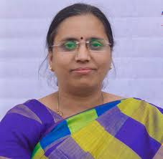
Dr. M.V. Padmavati is Professor and HOD (CSE) at Bhilai Institute of Technology, Durg (C.G). She obtained her master’ degree from MANIT, Bhopal and PhD from Thapar University in 2012.She also did her Postdoc from Silesian University, Czech Republic. Her Broad research interests are in the areas of Formal languages and Natural Languages Processing. She is having publications in several reputed journals and conferences.

